Assignment

**ASPIRIAN :** JEEVA ARAVINTH J V **EMAIL ID:** 2k19me070@kiot.ac.in

**DATE:** 12-02-2023

**TOPICS LEARNED**

**Services in Angular:**

First before using Services, I will create button and label component in the project. The main objective of the services in angular is to reduce the redundancy of the code in different components. The repeated codes are segregated in the services and it is injected in the multiple components.

Button components will be created using **ng g c button** command and **ng g c label** is used to create label component.

**In Button.component.ts**

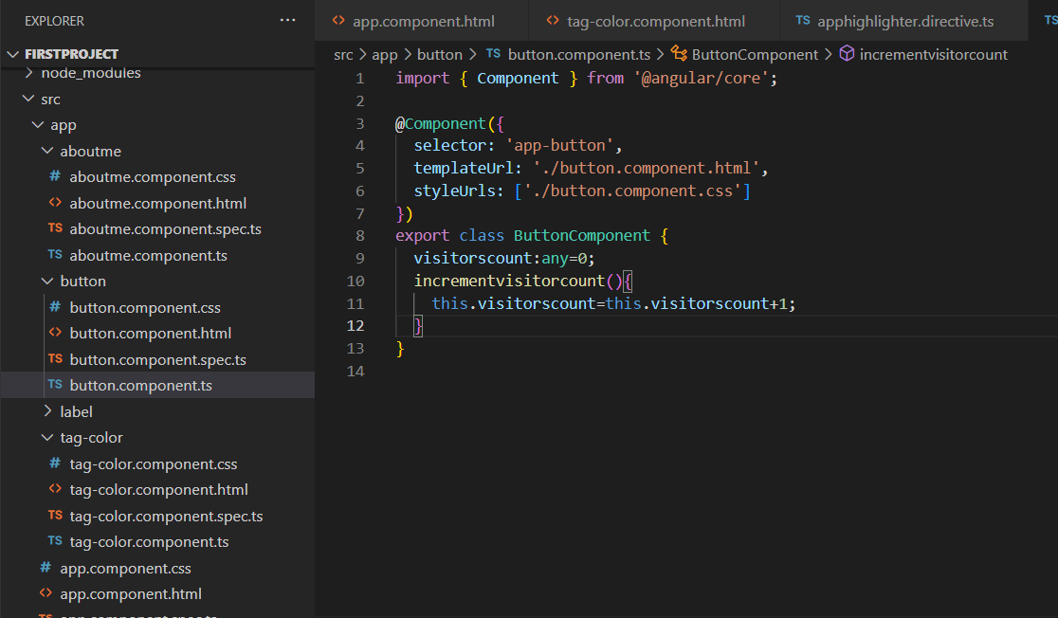

**In Button.component.html**

<p>button works!</p>

<p>Visitors count:{{visitorscount}}</p>

<button (click)="incrementvisitorcount()">Change</button>

**Output:**

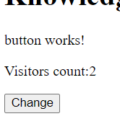

In above when the change button will click the count will be increasing in the visitors.

**In label.component.ts**

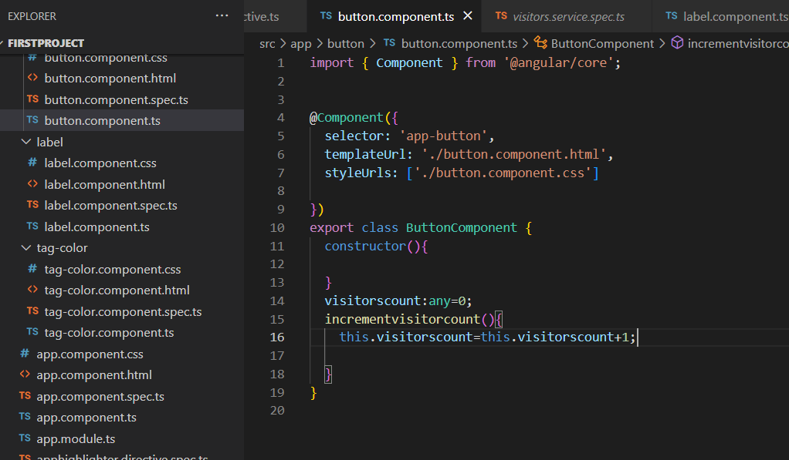

**In label.component.html**

<p>label works!</p>

<p>Visitor count : {{visitorcount}}</p>

<button (mouseenter)="incrementvisitorcount()">Change</button>

In above two cases the codes are repeated. The same functionality is done for both the component of button. So in order to avoid redundancy the services are used and it is injected into the required components. First it is injectable decorative to make the class as services and return the value to the multiple components.

**To generate service in Angular:**

**ng g s visitors 🡪** It is used to generate the service with .ts and .spec.ts files in the project.

**In visitors.service.ts**

import { Injectable } from '@angular/core';

@Injectable({

  providedIn: 'root'

})

export class VisitorsService {

  constructor() {

  }

  visitorcount:any=0;

  incrementcount(){

    this.visitorcount=this.visitorcount+1;

    return this.visitorcount;

  }

}

**In button.component.ts**

import { Component } from '@angular/core';

import { inject } from '@angular/core/testing';

import { VisitorsService } from '../visitors.service';

@Component({

  selector: 'app-button',

  templateUrl: './button.component.html',

  styleUrls: ['./button.component.css'],

  providers:[VisitorsService]

})

export class ButtonComponent {

  constructor(private service:VisitorsService){

  }

  visitorscount:any=0;

  incrementvisitorcount(){

    this.visitorscount=this.service.incrementcount();

  }

}

**In label.component.ts**

import { Component,OnInit } from '@angular/core';

import { VisitorsService } from '../visitors.service';

@Component({

  selector: 'app-label',

  templateUrl: './label.component.html',

  styleUrls: ['./label.component.css']

})

export class LabelComponent implements OnInit {

  ngOnInit() {

  }

  constructor(private service:VisitorsService){}

      visitorcount:any=0;

      incrementvisitorcount(){

        this.visitorcount=this.service.incrementcount();

      }

}

By using above code, the services are injected into the components and it is shown as the same output as above visitor count.

**Output:**

